British Sprint Triathlon Championships – 27th May 2012

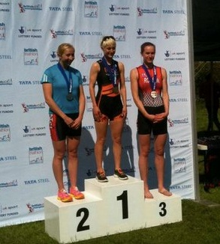
The National Sprint Triathlon Championship certainly lived up to its’ name this year, with a sprint down to the line almost requiring a photo-finish! Certainly the closest race result I have been involved in…
Emberton Park couldn’t have hoped for better weather to host the event - with blue skies, sun, and warm water for the swim. Almost alien conditions for a UK triathlon!
It couldn’t have been more different from the National Aquathlon last week, where I suffered in the cold and had a poor swim. With no such excuses possible today, my first target was to get a decent swim time! First mission was accomplished as I exited the water in 11:48. I was in 20th place, which sounds a long way down, but it was only one minute behind the leader. It just goes to show the depth of quality in women’s triathlon at the moment!
A quick T1, falling out of the Zone3 Vanquish (easy when you can feel your hands and feet!) and it was onto the bike. Time to start catching people!
I had been making adjustments to the setup of the Twinfoil all week, since in previous races I felt I wasn’t getting maximum power from my position. I was even experimenting with the saddle height and cleat placement during my recce of the course the day before! The alterations definitely seemed to pay off, as I clocked one of the fastest womens’ bike splits of the day (32:33) in near perfect conditions.
I was not sure of my exact position going into T2; often my fiancé Simon tries to count the number of ladies ahead and let me know, but he was occupied assisting a competitor from wave 1 who had crashed and broken her collarbone!
Not that knowing the position makes any difference to my strategy, which is simply to run hard, and catch as many people as I can! I just hoped I had put myself into contention for a medal if I could pull off a good run…
There were class athletes all around me in transition - last year’s winner (and current National Duathlon AG Champion) Anna Turvey was just behind me off the bike. World Triathlon AG Champion (and top runner) Kate Robson was just ahead, so my first aim was to keep her in my sight for the 5k as I knew then I’d be on for a good time.
To my surprise I found that I was closing the gap, and managed to catch Kate. We were passing dozens of ladies but it was hard to tell who was on the same lap or in the same wave! With 1km to go I spotted Stacey Penn (last year’s silver medallist) who had led out the swim, and another athlete who appeared to be sitting in for the ride. I knew it was time to make a move…
No sooner had I passed Stacey, the other athlete (who I didn’t know) took on the chase- with 300m or so to go, it was going to be a wind-up sprint to the line…
At this point the course went off the tarmac onto rough grass, and got narrower. There were other athletes on the course from Wave 1 so we had to weave around, but we hit the finishing straight neck and neck. I had the racing line - the inside corner - but the other athlete decided to obstruct and elbow me off the course, meaning I lost momentum. As she put in another kick, with only 50 yards to go there was not enough time to regain speed and catch back up.
Although my overall run time had been 36 seconds faster (2 seconds off the fastest ladies run time) it was not enough. We were given identical chip times, but I had to settle for second, while she was awarded the overall win. It was some consolation to win my age group, and I can take satisfaction knowing I had the potential to win the National Championships!

