European Ironman 70.3 Champs, Wiesbaden, Germany 12th Aug 2012

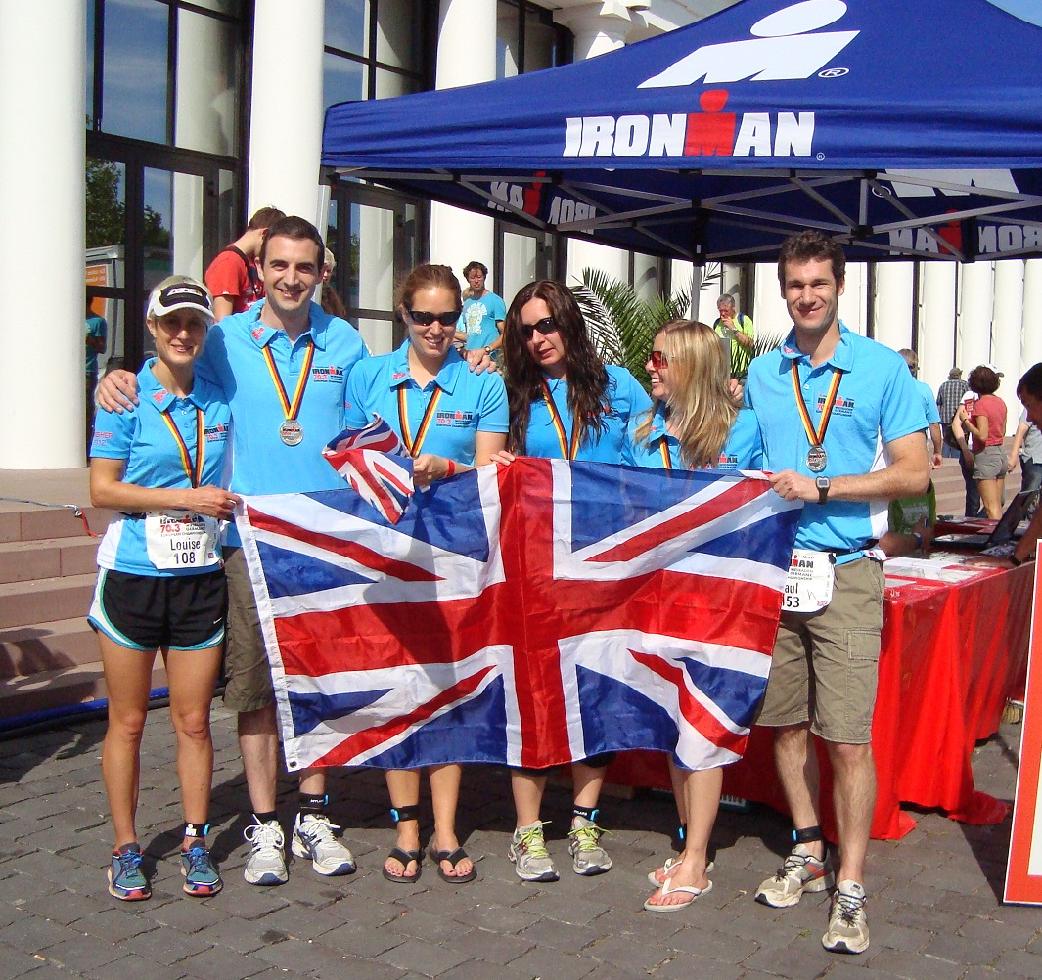
Team TVT!

Wiesbaden 70.3 was my debut long distance race, having never raced beyond Olympic distance before. Ever the fan of throwing myself in at the deep end, why not start with the European Championships at one of the toughest courses?!
When I entered the race (as a social outing with friends from Thames Valley Triathletes), my aim was simply to make it to the finish-line pasta party. But somehow many more goals got added in the lead-up to the event! On race day I was hoping for a 30 minute swim, a 1:30 half marathon, and to beat at least one of the pros…
Race day began with an eerie but exciting walk in the dark through the woods to the swim location - the beautiful and balmy Raunheim Waldsee. At 23 degrees it was only just wetsuit legal! The womens (all ages) with men 50+ was the largest wave of the day, setting off 5 minutes behind the pros. I chose to start on the far left of the swim, although it was the furthest route to the turn buoy I wanted to stay out of trouble and avoid being beaten up! I took things fairly easy in order to pace myself for the long day ahead, so was very pleased find out in the results I’d met my first goal of 30 minutes.
One discipline down, I was in 18th place in the field, but with still over 90% of the race to go- it was onto the bike. My first long-distance mistake was not researching the bike course, expecting it to be pretty much flat as Sprint/Olympic Championships usually are. Secondly – and partly due to several months upheaval of moving house – simply not having enough time to get enough miles or hills in to my training.
So finding out that the course had 1500m of ascent over the 90k was not the best news for me. The biggest climb even made my ears pop! I had been hoping to pace the bike and save something for the run, but there was nowhere to hide from the relentless hill climbs. The descents also kept the adrenaline high- whether they were straight lines encouraging speeds of over 50mph, or tight corners ominously lined with hay bales! I had a moment when someone else’s water bottle fell out under my wheels on one of the 50mph descents- no idea how I managed to avoid it!
Germany is renowned for their über-bikers, and you can see why with this kind of terrain to practise on! Although I overtook a few women, having put myself in such a high position on the swim, there were far more riders behind me aiming to get past. Unlike the shorter distances where you can try and race your rivals, up your speed and try not to let them out of sight… over this distance if you don’t pace yourself you will pay for it! So frustratingly I just had to stick to my own effort. By half way round (already further than OL distance) I was wondering if the bike would ever end! Surely there can’t be any more climbs? Fortunately the nice scenery, great weather and massive crowd support made the time pass better, along with the odd shout of ‘nice bike’- the Wilier Twinfoil certainly attracts attention wherever it goes!
After 3 hours and 11 minutes of riding, it was finally into T2. My legs not used to all these hills, already felt like they were going to cramp. I couldn’t set off at my usual run pace, knowing that would likely result in seizing up completely. I just had to keep moving at as reasonable pace as possible without making things worse. I also knew I had to keep getting the nutrition in but I was getting very sick of gels!
The run was a 4-lap course around Wiesbaden Kurpark, and while there were no proper hills, it was a false flat- slightly up on the way out, slightly down on the return. It was also quite twisty and mainly on gravel- even without cramping legs it was not going to be a fast course. And now in the midday heat of high twenties, perhaps 30 degrees… I would have to revise my expectations of a 1:30 run.
Every lap seemed to get longer, so I just had to set myself new mini goals of getting to each aid station and looking forward to water, cola and sponges! I knew I was getting slower each lap- the finish line couldn’t come soon enough for me. I kept wondering how people can do a full Ironman??
Finally after a total time of 5:25 I crossed the finishing line, surprisingly enough I felt quite sick from the OD of gels and energy drinks, and could not actually eat the food from the ‘athletes garden’ which I had been so much looking forward to! There was plenty of time to chill out though, get a shower, a massage, find out the results and get my appetite back in time for pasta with my club mates.
Looking down the results I was happy to find I had beaten one of the Pros! Yessss! Although I’d run a disappointing half marathon time of 1:38, 2 out of 3 goals ain’t bad…
Overall I finished 23rd of the non-professionals and 3rd Brit. 7th Overall in my Age Group. Not too bad for my first attempt at 70.3, and given the high level of competition at a European Championship.

