National Cross Tri Championships, Coniston MTB Triathlon, 10th June 2012

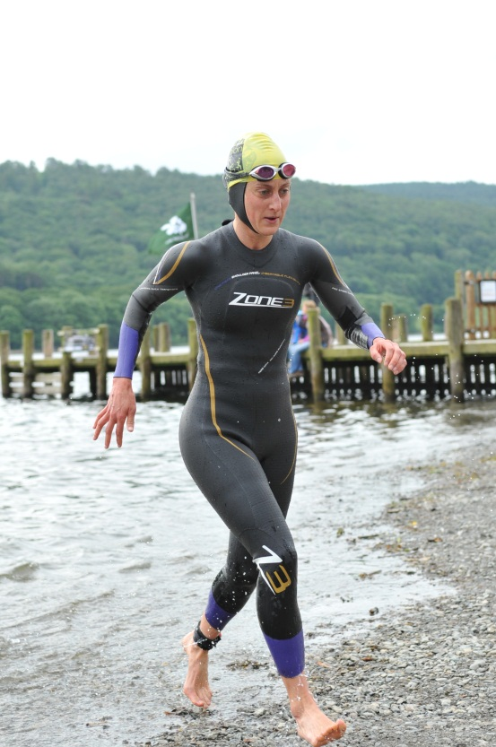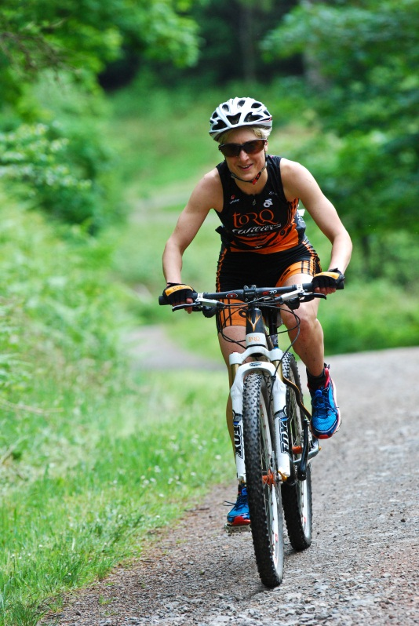
I have wanted to give an off-road triathlon a try for years, so why not throw myself in at the deep end by entering the National Champs as my first race?!
There are no separate off-road Championships for Age Groupers and Elites, so all would compete together for the coveted British Titles. There would also be one mass start for men and women of all categories - it’s not every race you get to line up alongside the likes of legendary Olympian Tim Don!
We were warned the swim would be a cold one, but we were not warned it would be closer to 1900m than 1500m! Apparently Coniston water is too deep to anchor the buoys anywhere but the edges, so two extra-long laps it was to be! Traditionally a long swim would have been a disadvantage to me, but all the extra hours put in over the winter would hopefully pay off.
Unsurprisingly ‘The Don’ was first to exit the water, together with pro XTerra Triathlete Rory Downie. More surprisingly, I was very pleased to exit with the front pack only 5 minutes later - 21st in the field overall and 3rd woman. So far so good!
After a 500m road run to T1 (requiring shoes!) it was into transition and onto the bike. The bike course began with a massive climb up to Grizedale forest - firstly on roads (where I did feel a bit lost without my aero bars!), then fire roads, and finally off the beaten track. Still more climbing to come though, up to the purpose built single-track loop. An ideal warm-up after a freezing swim!
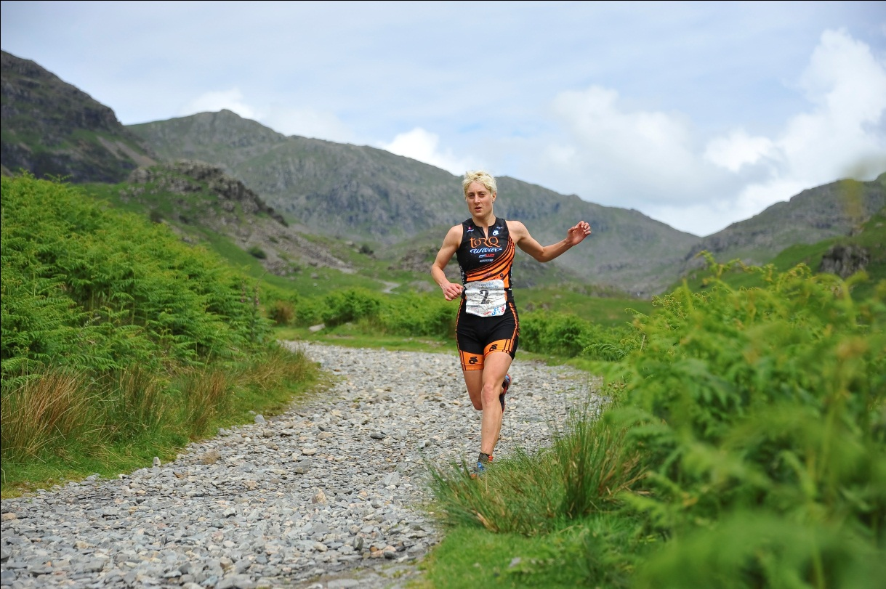
I had already overtaken one of the ladies by the top of the non-technical climb to move up into 2nd place. However the technical stuff now began, and this was a mountain biker’s course - in the words of last year’s winner (another pro, Doug Hall, who would finish 4th this year) ‘The North Face Trail: it's graded red, which means it's difficult! Both technically and physically this trail is steep (up and down) and difficult to ride at speed. Technically proficient mountain bikers will make up lots of time on this course.’
For me it was a case of holding my own on the climbs and trying not to lose too much time on the descents, plus trying simply to stay on the trail and not crash! There were wet and narrow wooden boardwalks (with no chicken wire!), bridges made of boulders, drop-offs and wet roots to navigate - as well as the general nature of the trail being very rugged and rocky.
I had ridden round the course 3 times in the preceding days, plus some additional practise at nearby Whinlatter Forest, and while I had rather tired legs, I decided it was a worthwhile trade-off to try and pick up some skills, and definitely an advantage knowing the course.
My adrenaline reserves had been pretty much consumed by the end of the singletrack, however there was still the huge descent down what can only be described as a mud, grass and gravel off-piste bank, to get back to the road! I was very cautious here but I’d seen someone crash during the pre-ride and it wasn’t worth taking a risk at this point when I was in 4th place, and still my strongest discipline, the run, to come.
Having cycled in my running shoes (giving away my novice status on the mountain bike!) there was no need to change them, so I had the fastest T2 of the day (19 seconds).
The run course went directly up out of Coniston village, heading for the slopes of the Old Man. It was a true fell run, so steep that a combination of running and walking proved the best strategy. Less than halfway up the climb, I passed the 3rd placed lady to move into bronze position myself. Then once at the top it was home and dry - well almost - as I flew down the hill I lost a shoe in a bog and had to go back to retrieve it! Other than that it was an enjoyable and scenic run, with only a few men in sight to overtake.
I clocked the second fastest run of the day, with the fastest being overall winner (and Cross-Tri Pro) Kerry MacPhee. I had finished 3rd overall and first in my age group – a great way to finish my off-road debut.
